The height of a binary tree is the number of edges between the tree's root and its furthest leaf. For example, the following binary tree is of height 2 :

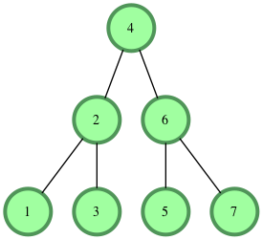

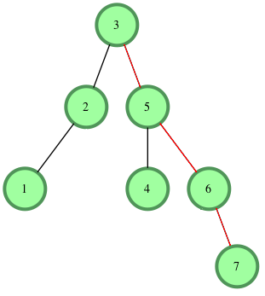

There are  nodes in this path that are connected by  3 edges, meaning our binary tree's .